

Experiment 3

Setting Up Hybrid Cloud Connectivity Using Cisco Packet Tracer (Simulation)

AIM:
To simulate a secure hybrid cloud connection between an on-premises data center and a cloud network using routers, switches, subnets, and routing in Cisco Packet Tracer
PROCEDURE:
Step 1: Open Cisco Networking Academy
Go to: https://www.netacad.com
Step 2: Create a Free Account or Sign in with your Google Account
1. Click Create an account (or Sign up).
2. Enter:
o First Name
o Last Name
o Email Address
o Password
3. Verify your email if prompted.
4. Sign in.
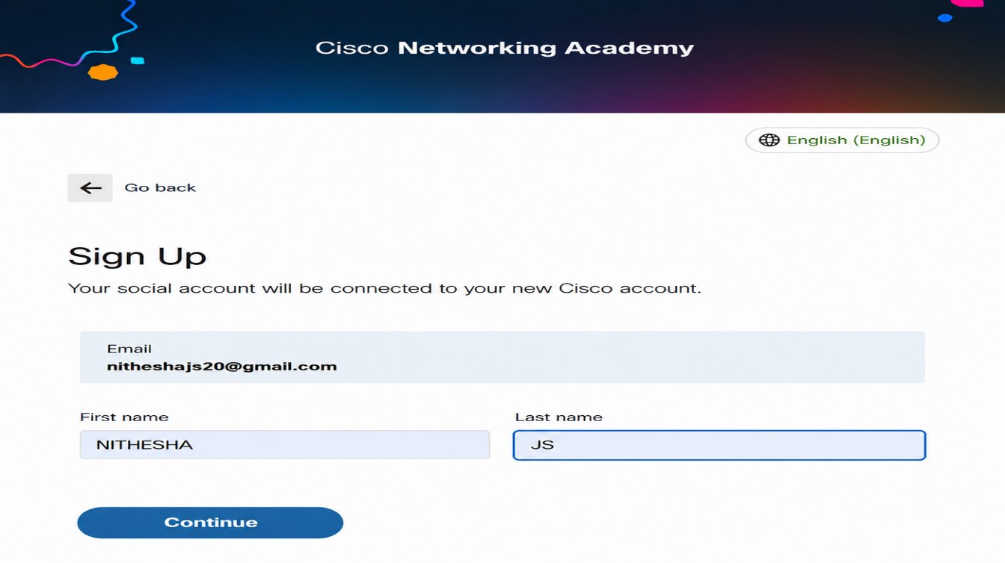

Step 3: Enroll in the Free Packet Tracer Course
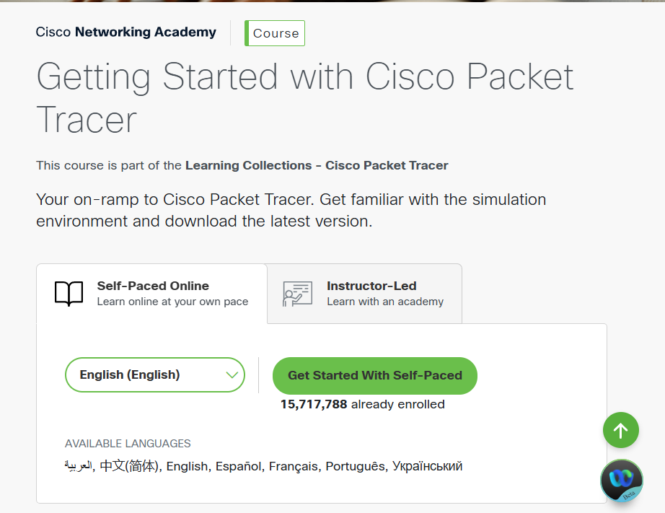
Step 4: Download Packet Tracer
After enrolling:
1. Go to your NetAcad Dashboard.
2. Open the Getting Started with Cisco Packet Tracer course.
3. Navigate to the Resources or Downloads section.
4. Download the version for your operating system:
o Windows 64-bit (recommended for most PCs)
o macOS
o Linux

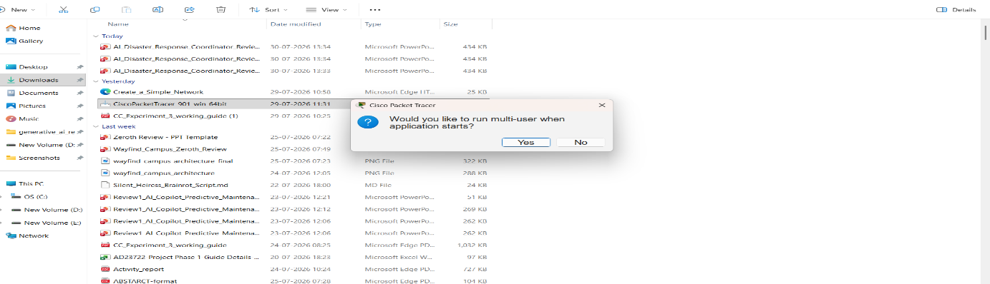

Step 5: Install Packet Tracer
1. Open the downloaded installer (.exe on Windows).
2. Click Next.
3. Accept the license agreement.
4. Click Next until installation completes.
5. Click Finish.
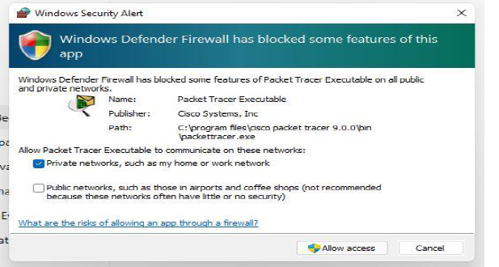
Step 6: Start Packet Tracer
Open Cisco Packet Tracer from the Start Menu.
Sign in with your Cisco NetAcad account or sign in with your google account.
Step 7: Place Two Routers
At the bottom-left of Packet Tracer, you'll see several icons.
1. Click Network Devices (the router icon).
2. Click Routers.
3. Choose 2911 (or 1941 if 2911 isn't available).
4. Click once in the blank workspace to place the first router and second one
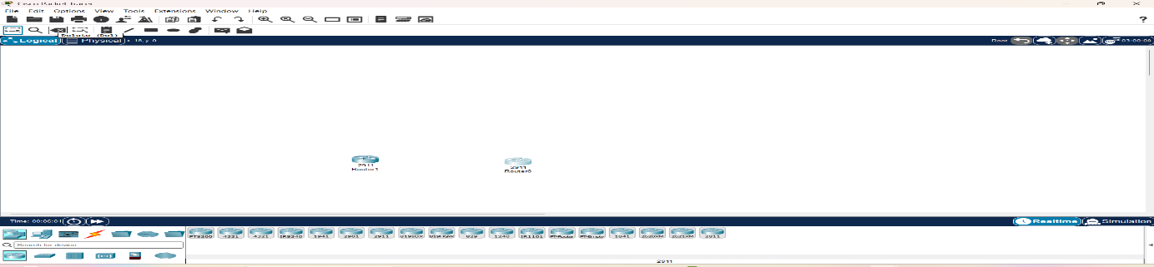

Step 8: Place Two Switches
1. At the bottom-left, click Network Devices.
2. Click Switches.
3. Select 2960 (for example, 2960-24TT).
4. Place one switch below Router0.
5. Place another switch below Router1. 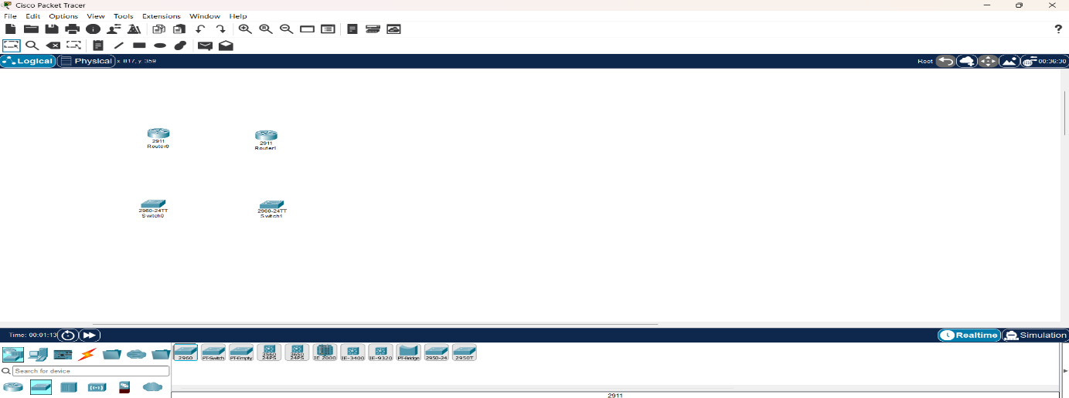

Step 9: Place One PC and One Server
1. At the bottom-left, click End Devices (computer icon).
2. Select PC.
3. Place it to the left of Switch0.
4. Select Server.
5. Place it to the right of Switch1.
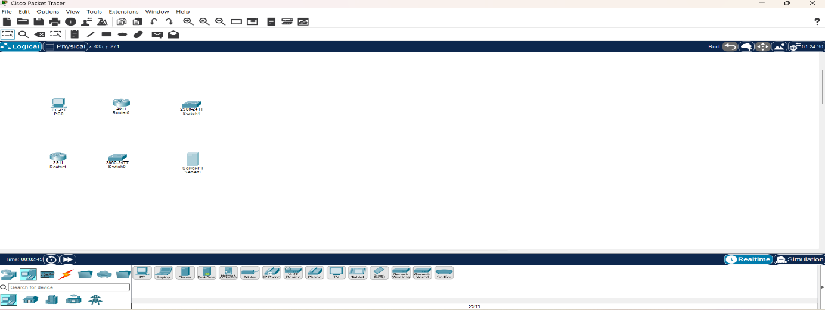

Step 10: Connect the Devices
At the bottom-left, click the Connections icon (⚡ lightning bolt).
Choose Copper Straight-Through (usually the first black cable).
Connection 1: PC to Switch0
1. Click PC.
2. Select FastEthernet0.
3. Click Switch0.
4. Select FastEthernet0/1 (or any free FastEthernet port).
Connection 2: Switch0 to Router0
Using the same Copper Straight-Through cable:
1. Click Switch0.
2. Select FastEthernet0/2.
3. Click Router0.
4. Select GigabitEthernet0/0.

Connection 3: Server to Switch1
Again use Copper Straight-Through:
1. Click Server.
2. Select FastEthernet0.
3. Click Switch1.
4. Select FastEthernet0/1.

Connection 4: Switch1 to Router1
Again use Copper Straight-Through:
1. Click Switch1.
2. Select FastEthernet0/2.
3. Click Router1.
4. Select GigabitEthernet0/0.

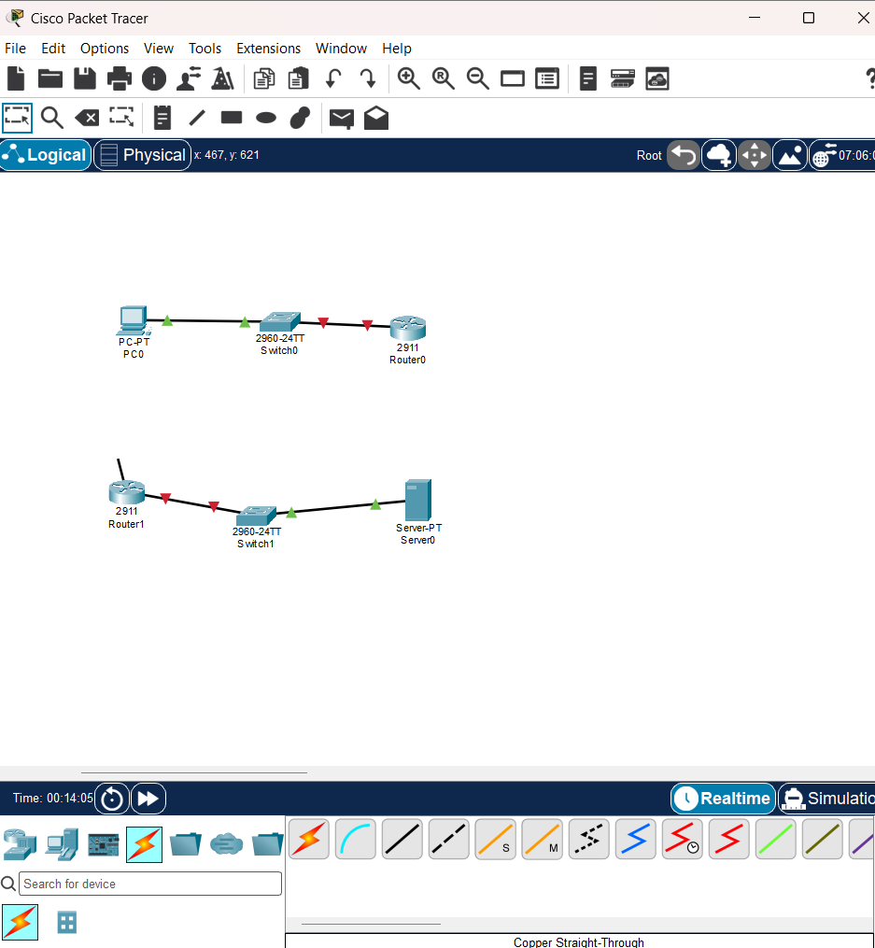
Step 10.1: Connect Router0 to Router1
Now connect the two routers.
Option A (Recommended)
Use Copper Cross-Over.
1. Click the Connections icon.
2. Select Copper Cross-Over.
3. Click Router0.
4. Select GigabitEthernet0/1.
5. Click Router1.
6. Select GigabitEthernet0/1.
Your topology should now look like this:
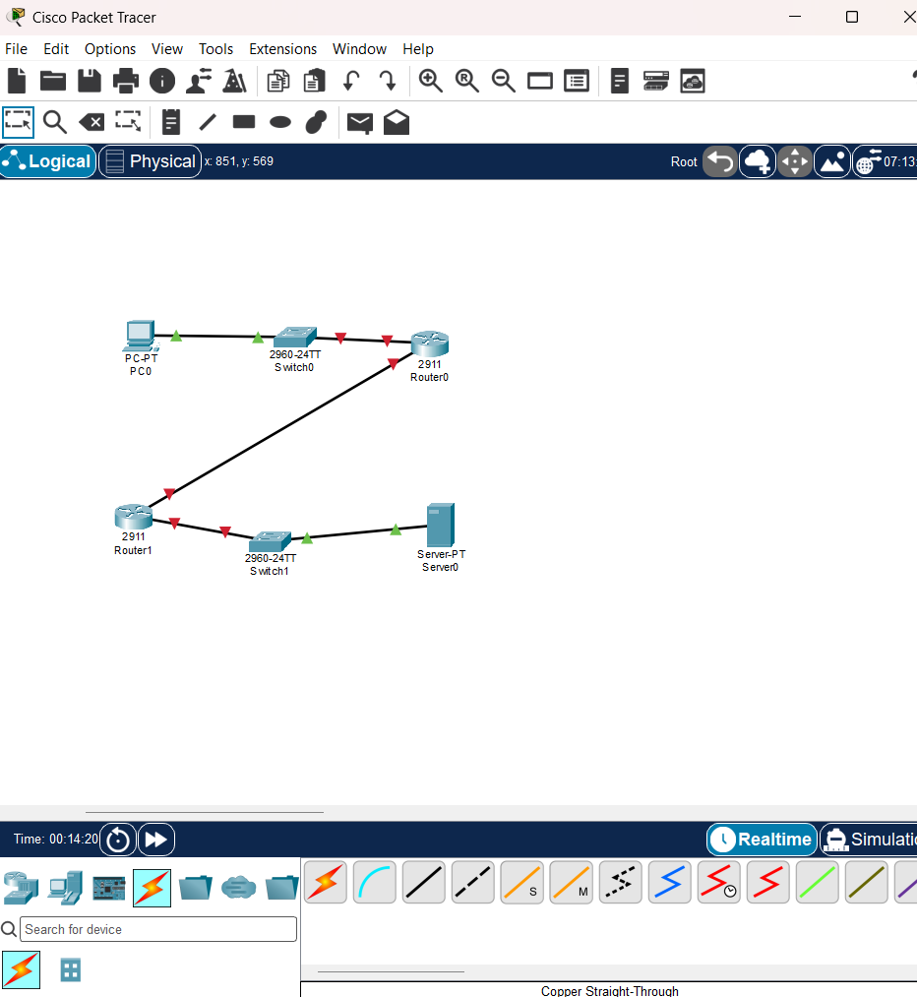
Step 10.2: Click the Router
In your workspace, left-click Router0 once.
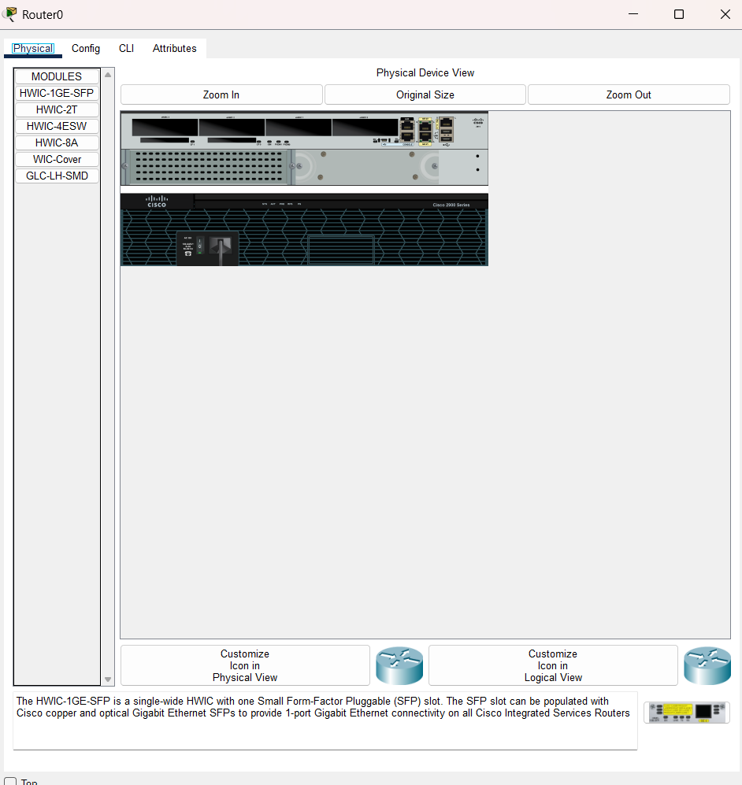

1. Click the CLI tab.
2. If it asks:
Continue with configuration dialog? [yes/no]:
Type: no Press Enter. When you see: Router>
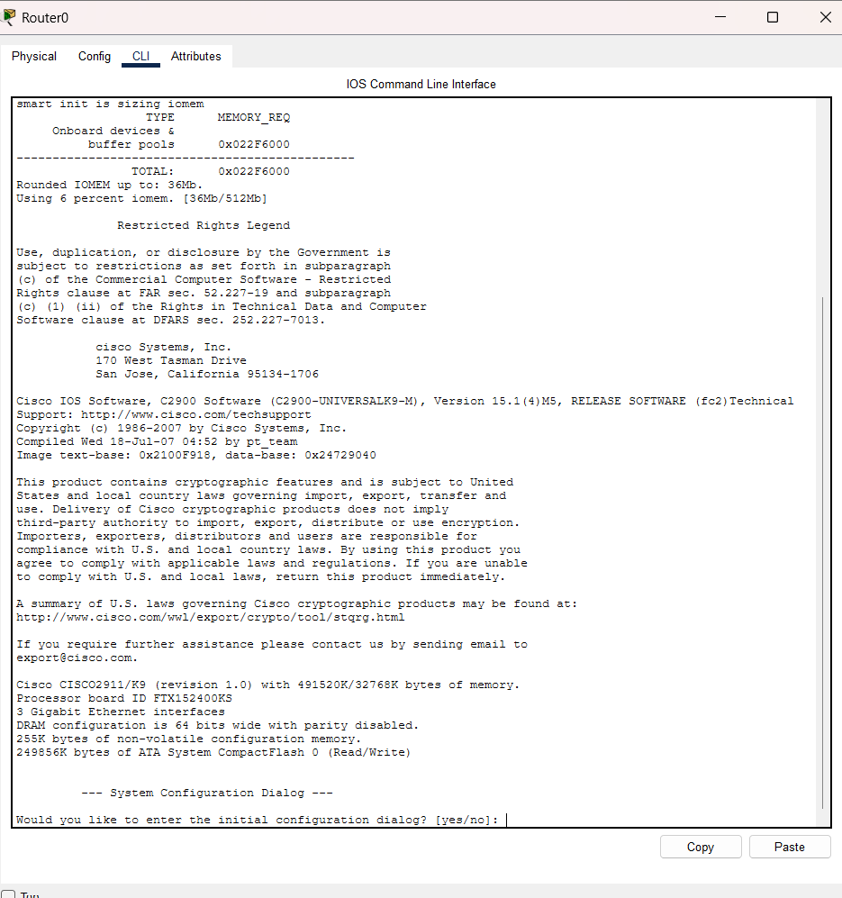
Step 10.3: Configure the LAN Interface (Connected to Switch0)
At the Router(config)# prompt, type these commands one at a time, pressing Enter after each line.
interface gigabitEthernet0/0
You should see:
Router(config-if)#
Now type:
ip address 192.168.1.1 255.255.255.0
Press Enter.
Now type:
no shutdown
You should see a message similar to:
Now
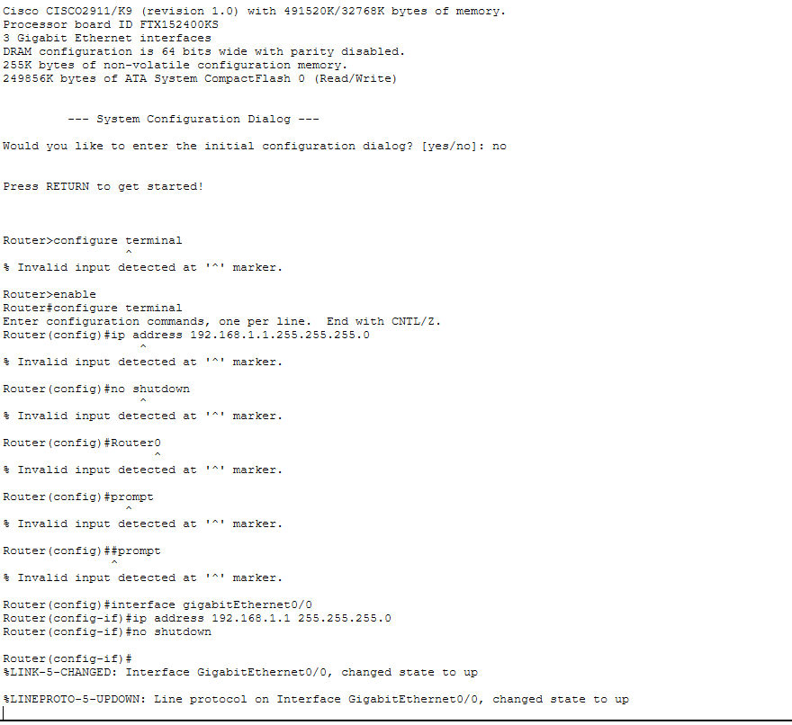

Step 10.4: Configure the Router-to-Router Interface
Now type:
interface gigabitEthernet0/1
Then:
ip address 10.10.10.1 255.255.255.252
Then:
no shutdown
Again, wait for the interface to come up.
Finally, type:
exit
You should now be back at:
Router(config)#
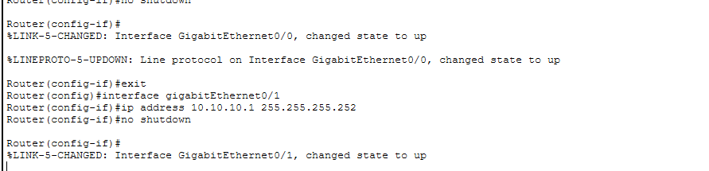
Step 10.5: Verify the Configuration
Type:
do show ip interface brief
Since you're in configuration mode, use do before the show command.
You should see something similar to:
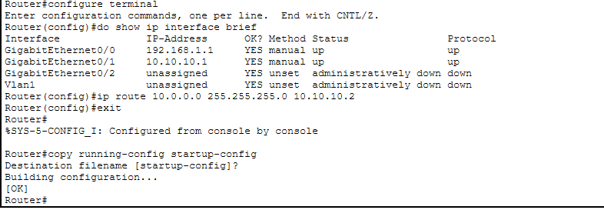
Next Step: Configure Router1
Click Router1 → CLI.
If it says:
Press RETURN to get started!
Press Enter.
If it asks:
Continue with configuration dialog? [yes/no]:
Type:
no
Then enter these commands one by one:
enable
configure terminal
interface gigabitEthernet0/0
ip address 10.0.0.1 255.255.255.0
no shutdown
exit
interface gigabitEthernet0/1
ip address
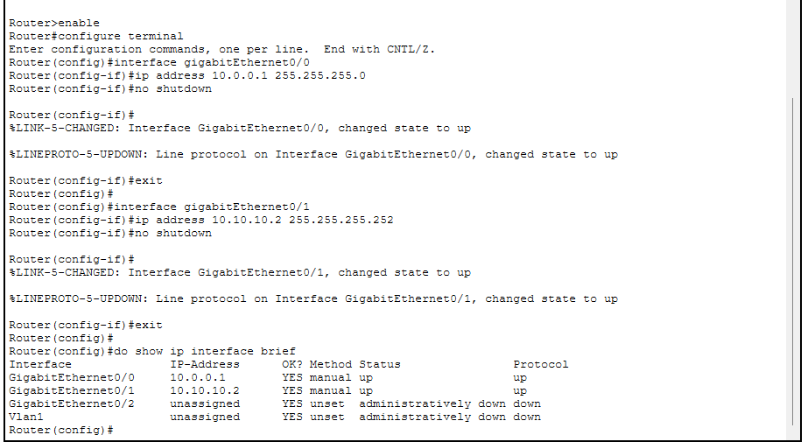

Step 10.6: Configure the PC
1. Click PC.
2. Select Desktop.
3. Click IP Configuration.
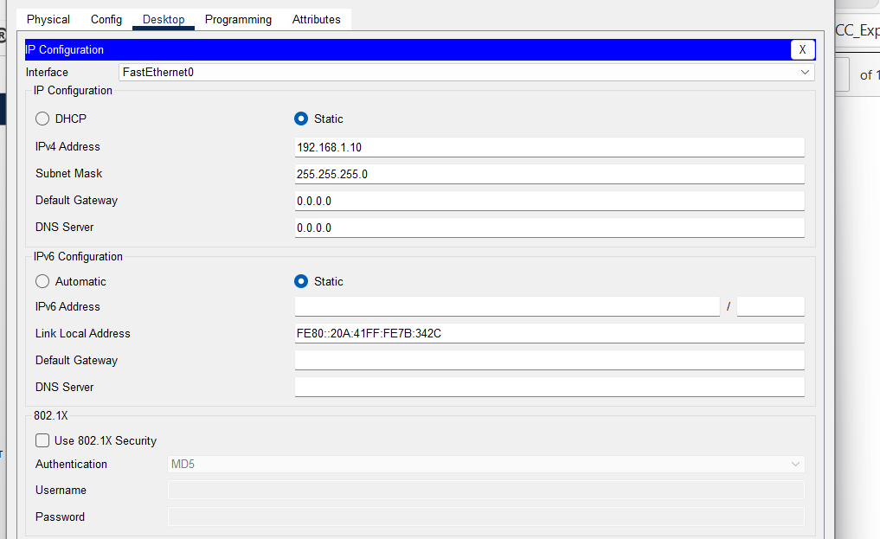

Step 10.7: Configure the Server
1. Click Server.
2. Select Desktop.
3. Click IP Configuration.
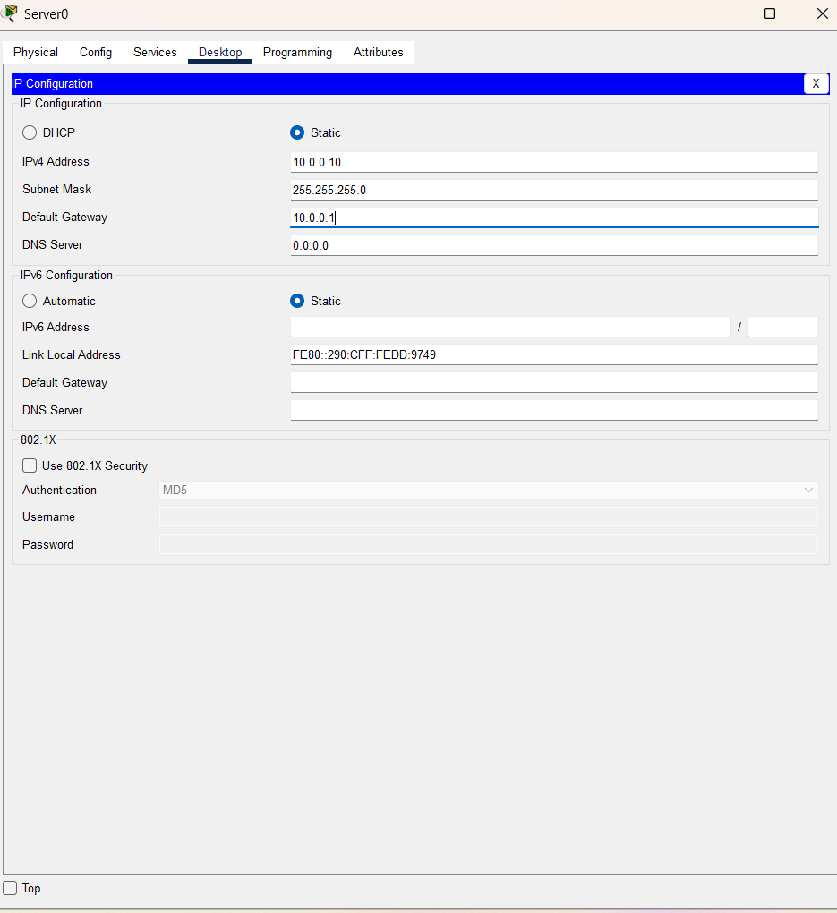

Step 11: Configure Static Routes
A. Configure Static Route on Router0
1. Click Router0.
2. Go to the CLI tab.
3. If you're at Router#, type:
configure terminal
Now enter:
ip route 10.0.0.0 255.255.255.0 10.10.10.2
Exit configuration mode: exit
Save the configuration: copy running-config startup-config
When prompted: Destination filename [startup-config]? Just press Enter.
B. Configure Static Route on Router1
1. Click Router1.
2. Open the CLI.
At the Router# prompt, type: configure terminal
Now enter: ip route 192.168.1.0 255.255.255.0 10.10.10.1
Exit: exit
Save the configuration: copy running-config startup-config
When prompted for the filename, simply press Enter.

C. Verify the Route
Type: show ip route
You should see a line similar to: S 192.168.1.0/24 [1/0] via 10.10.10.1
The S indicates that the static route has been added successfully.
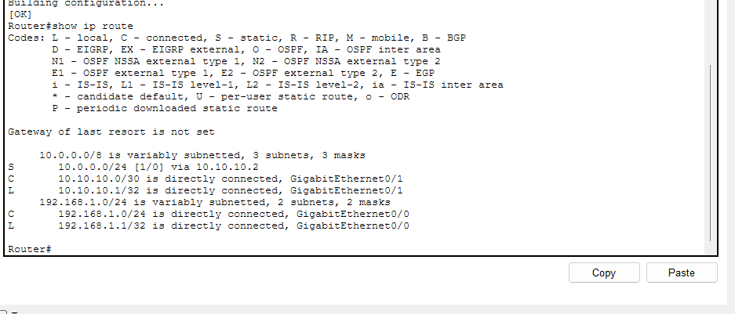
Now let's verify Router0
On Router0, at the Router# prompt, type: show ip route
You should see a line like: S 10.0.0.0/24 [1/0] via 10.10.10.2

If you don't see it, add the route:
configure terminal ip route 10.0.0.0 255.255.255.0 10.10.10.2
end copy running-config startup-config
Press Enter when it asks for the destination filename.
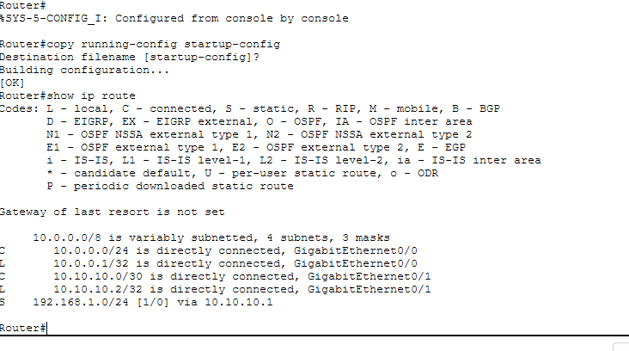
Step 12: Test Connectivity
From the PC
1. Click PC.
2. Go to Desktop → Command Prompt.
3. Type: ping 10.0.0.10
4. Type one more time: ping 10.0.0.10

Experiment Successfully Completed!
You have successfully simulated Hybrid Cloud Connectivity.

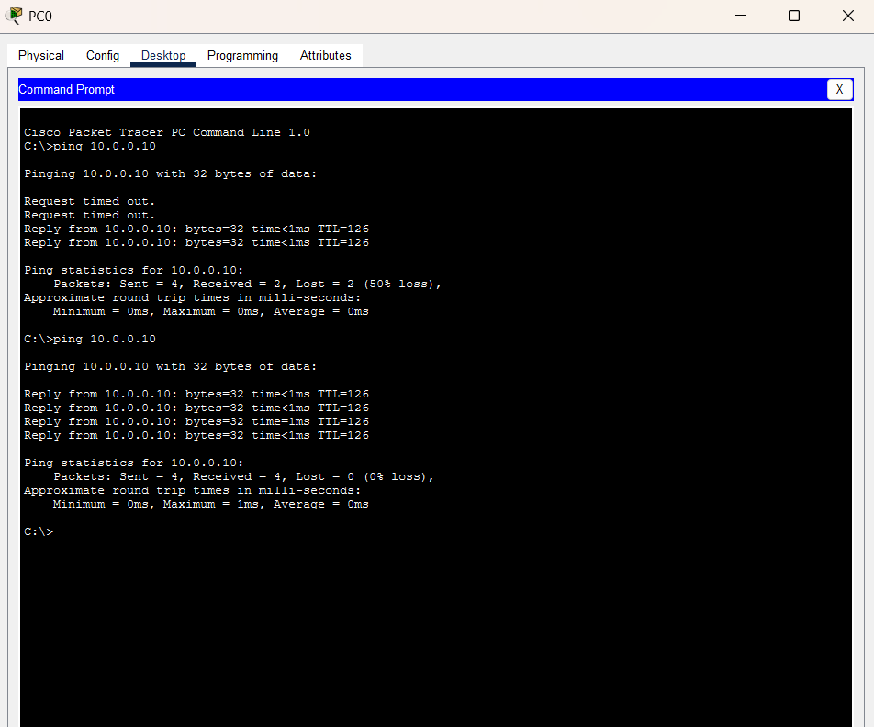
Architecture Diagram of Simulation

Result:
A hybrid cloud network was successfully simulated using Cisco Packet Tracer. The on-premises network and cloud network were interconnected through routers configured with static routing. Communication between the PC and the cloud server was verified successfully using the ping command, demonstrating end-to-end connectivity.

